Knockin mouse models: https://getargeting-2026.vercel.app/knockin-mouse-models

- The AI generated images aren’t accurate enough. We need to discuss how to make ones that are more accurate. Wasn’t there a site you said we could purchase a subscription to that may have images available for use? In the meantime, this needs to be removed:
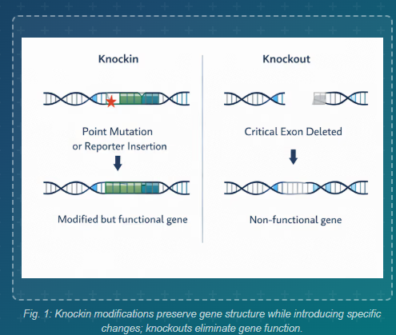

- Remove this image too, it’s not accurate enough:
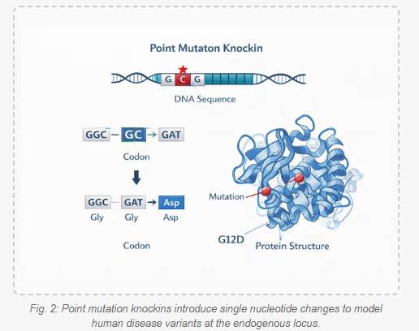

- Publications are accurate but again the format could be better (i.e. highlight the article title in a different color):
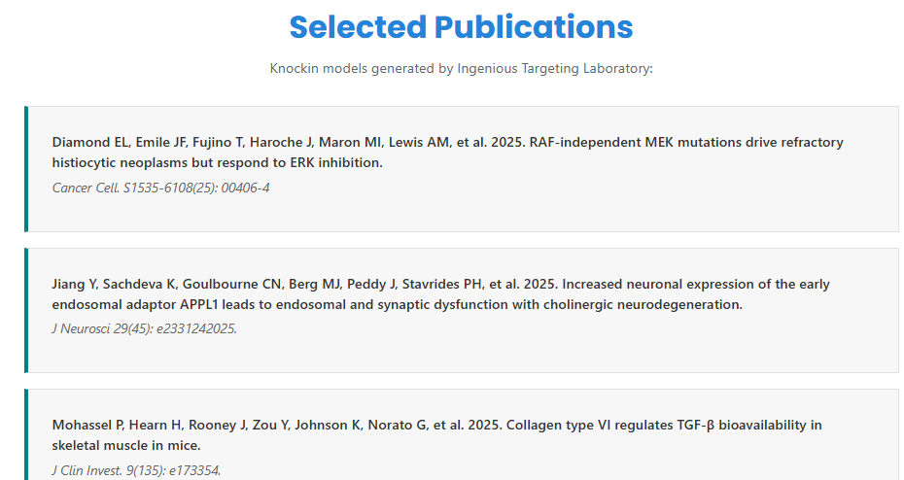

- I notice that depending on the page, the format for the testimonials is different and if it’s like this, it looks a bit sparse. So maybe we want to use a different format if we will highlight only one testimonial:
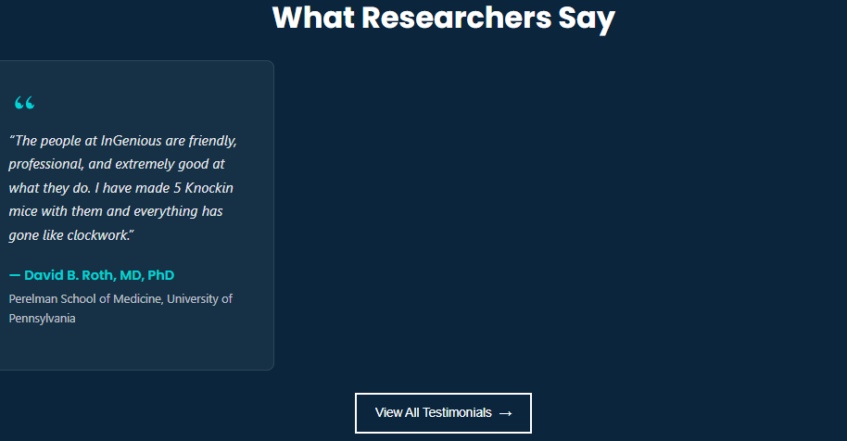

- Let’s remove all timeline questions:
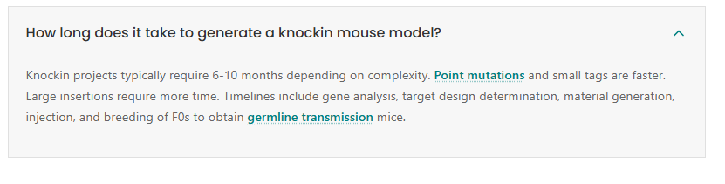

- Let’s remove the ES cell resource link and remove the page it links to completely. The timeline link and FAQ’s have a 404 error:
